March 11, 2021

Groton Planning Board
Town Hall
Groton, MA 01450

RE: Village at Shepley Hill

Dear Takashi and Members of the Planning Board,

I would like to respond, for the record, to certain comments in the letter dated March 8, 2021, from Attorney Jill Mann.

1. Unusual Topographic Conditions: While the description of the property is interesting, it has little to do with the need for a variance, in particular for the portion of the road from Longley Road that ascends the side of the drumlin. The drumlin is about 60 feet high and has a side slope of about 25%. The variance is required for that road because of the size and steepness of the drumlin, not because of other site constraints. The side of a drumlin is not an unusual topographic condition in Groton, nor are the sides of the large number of eskers, kames and other glacial landforms in Groton that would similarly require waivers if approached from the side.

2. Planning Board "Directive": The letter implies there is a "directive" from the Planning Board to have two means of egress. Two means of egress are required if a road is more than 1,000 feet. The applicant is requesting a longer road and because of that the second egress is required. The need for the longer road, and therefore the second egress, is simply to gain additional density. While access to an upland portion of land is often considered a right, utilizing waivers to construct a road requiring waivers in order to gain extra density and describing that as a "directive" from the Planning Board is misleading.

3. Precedent: It is true that most waivers do not set legal precedents, certainly as long as the waivers are not excessive, and appropriate rationale for granting the waiver is provided. In this case the waiver would apply to a significant length of road with an increase over the allowable fill up to more than 400% over allowable. Having served on the Planning Board and having also represented over 200 development projects for landowners and developers in Groton, I can say definitively that landowners and developers pay attention to waivers that are approved for other properties. Due to the extreme degree of this waiver and the fact that the only purpose of the waiver for the connecting road is to increase the density beyond what can be achieved without that waiver, it is hard to image how a future waiver request for excess cut or fill can be turned down by the Planning Board, or how a denial of such waiver could be defended in a court of law. Without the protection afforded by the cut and fill regulation, environmentally sensitive areas on a large number of properties throughout Groton would be opened up to development.

Respectfully,
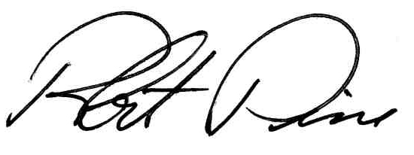
Robert Pine, PE FASLA

